1. How do you maintain your Automation code?

We do develop our automation scripts in our local machine, once deployed will commit the changes to Git repository.
In case, more than one person working on the same project.
If Git repository has latest code but not, you’re local one, at the time of Check-In the code tool will Ask you to 'pull with merge’. When you do this operation, whatever changes you have done Will be pushed to Git repository and at the same time latest code from Git will be Check-Out To your local repository.

2.How to you 'merge' the code to different repositories?

GitHub has provision to merge the code to different repositories.
We have an option available in GitHub called 'Merge Requests'.
Cliking this option,will ask you to select 'Source Brnach' and 'Target branch' and then click on 'Compare branches and continue' button.
Another window will open then Submit new merge request.
Then another window will open, click on 'merge' button to merge the code from one repositoty to another one.

Step-1:
1.Install git from the https://git-scm.com/downloads
2.Once installed git ,we can launch git from the git bash
3.From the git bash :
-To know the git commands
*git –> it will display all the git commands
-To know the git version
*git - -version – >it will show the git version
-To know the git help
*git --help -> it will display all the git commands with help messages
Step-2: signup a git account and sign into github
Uid - pythonsam
Eid : shyam.sam33@gmail.com / django@4859

git init, git clone , git bash
1.Create a github repository – “Python”
2. click on “clone or download “ – copy the https URL or ssh key [ copy https URL]
3.from git bash – go to drive d:/sdet folder
4. run the command : git clone https://github.com/pythonsam/Python.git
5.now it’s cloned the repository from the git hub to local machine
9.git bash : run command git init
10.run command git status : now it show’s the repository up to date or not

git add , git commit ,git push
1.got to project level cd :/sdet/abhibus
2.git add Data
Note : Above steps will add ‘Data’ Folder to Staging area .
3.git commit -m ‘ Added Data Folder to abhibus project ‘
Note : git commit adds your changes to local version control database
4.git push
Note: git push will now push committed changes to remote server (github in this case)
Now got to https://github.com/pythonsam/Python to see the changes
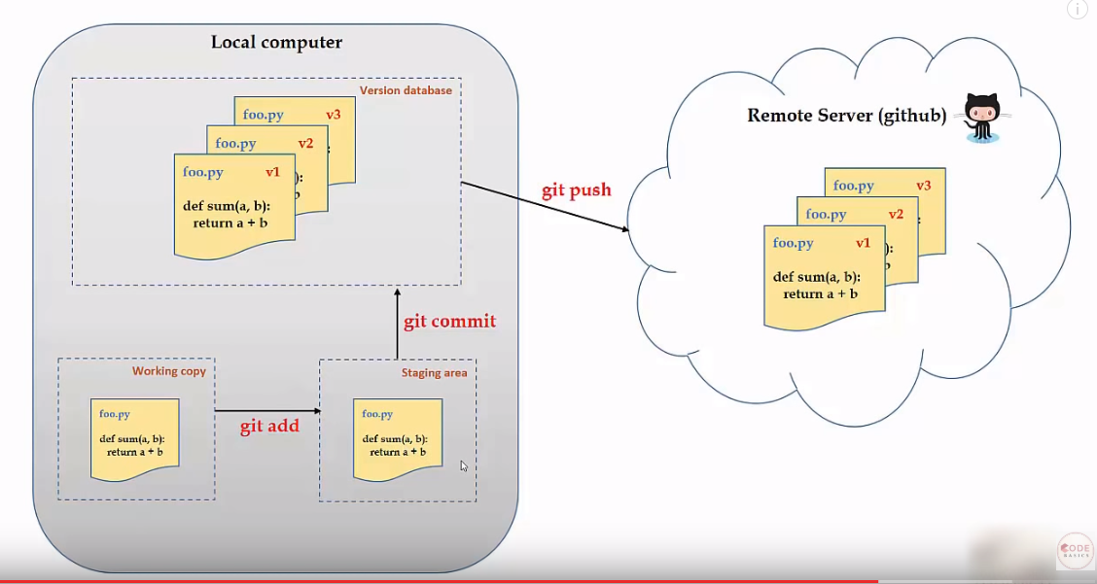

git checkout -- <filename> , git checkout -- . [FOR ALL FILES]
1.how to undo uncommitted changes
2.go to path d:/sdet/abhibus/Data
3.git checkout – Testdata.json –[ it will undo the changes for Testdata.json File ]
4.git checkout -- . [It will undo the changes for multiple Files]
--------------------------------------------------------------------------------------------------------------------------------------
How to undo committed changes
git revert , git revert -n
git revert – It will commit the changes
git revert -n – It wil not commit the changes
1.git revert <committed id>
2.To get the committed id after commit the changes <git log > then you will get the committed log id
3.use the git committed id by using below command
4.git revert c6583252f8dd0da9389a53b9e47a4b28adc92a10
5.then it will show summary for the committed the below screen

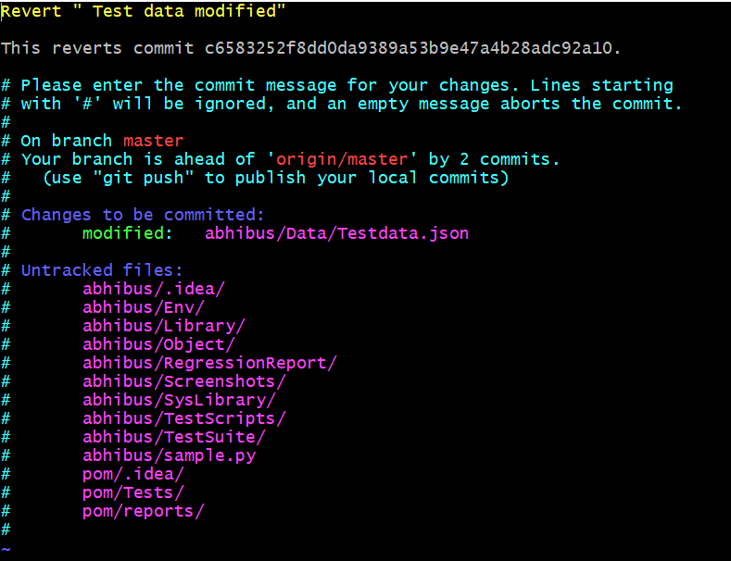
6.To come out from the above screen enter :q
7.How to revert the explicitly
git revert -n <committed id >
git commit -m ‘revert text >

--------------------------------------------------------------------------------------------------------------------------------------How do git reset
Reset the previous changes using git reset <committed id >
git log - u will get the all the log id
git reset hard -- <committed id>

--------------------------------------------------------------------------------------------------------------------------------------How to create branches
1.To Create a New Branch
git branch <branch name >
git branch thirsty
2.To Make Created branch active
git checkout <branch name>
git checkout thirsty
3.How to Merge 2 branches
If you want merge the thirsty branch into active branch (master branch)
git checkout master → make master branch active
git merge thirsty →This merge thirsty branch into active branch (master branch is this case )

4.How to get the created branch on remote server
git checkout thirsty → to make sure that thirsty branch should active
git push →It will below command to push the thirsty brach to remote server
git push --set-upstream origin thirsty

Now got to remote repository then check the created branch <thirsty > able to see under branches
5.Deleting branch
git branch -d [branch name]
git branch -d dummy
Note : To create a branch and make that branch active use below command
git checkout -b dummy -> It will create a branch make this branch as active

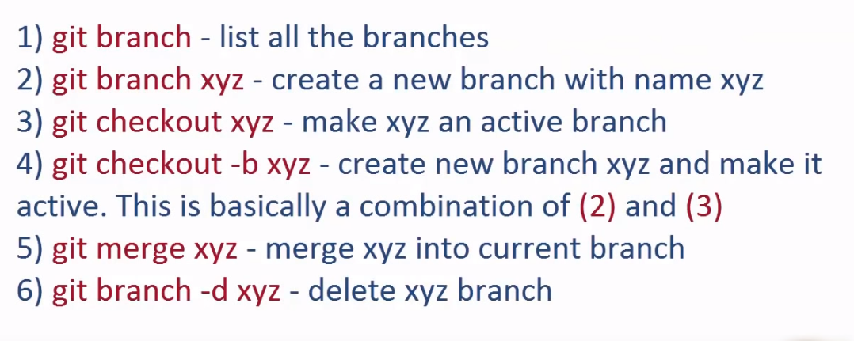
6.Git show head use:
git show head → It will show the recent commits
git difftool → difference between two commits
git difftool <log id2> <log id1> → it will display last two commits changes
git difftool HEAD~2 HEAD~1 →It will display last two commits changes

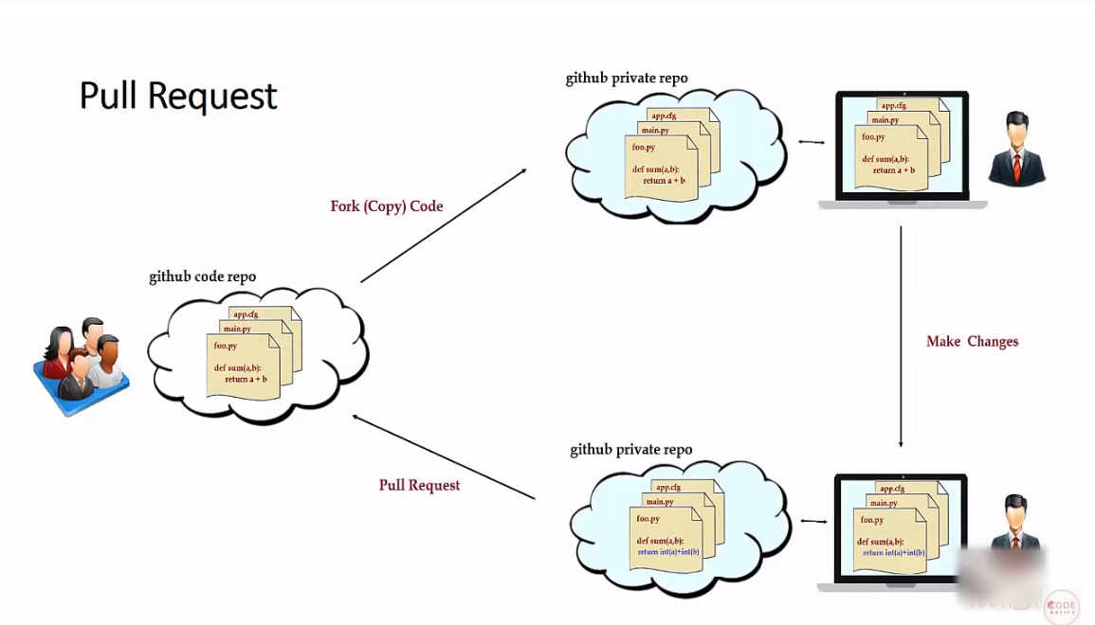

Interview Questions:
1.What is - -all ?
git push – all origin -- > [ Push all branches to your remote repository ]
2. How to switch branch
git checkout <branch name>

